The Demolition Man

Matteo Renzi is on a mission to remake Italy.

By Jane Kramer
Matteo Renzi is the youngest Prime Minister in his country’s history. “This year, I will change Italy or change jobs,” he says.Credit Illustration by Riccardo Vecchio; Reference: Dmitri Azarov / Kommersant Photo / Getty
Early this year, Matteo Renzi invited Angela Merkel to Florence for a tête-à-tête at the Romanesque guild-priory known since the Renaissance as the Palazzo Vecchio and now its city hall. Renzi comes from Florence and, like most Florentines, he is devoted to the city, which in his case elected him mayor in 2009, when he was thirty-four, and nurtured the native Machiavellian wiles that five years later brought him to Rome, at thirty-nine, as the youngest Prime Minister since Italy became Italy, in 1861. In Rome, the art of politics could be described as nets and tridents. Not Renzi’s style. In Florence, where the Renaissance charm of the city and the Renaissance stealth of its population still hold sway, Renzi is a master of both, so it isn’t surprising that late last year, when Merkel confessed that she’d visited Florence only once, he asked her to come again, this time as his guest. The papers called the invitation the Prime Minister’s charm offensive. Renzi, who had hoped for Merkel’s blessing on his requests to the European Commission for the time and financial flexibility to rescue the beleaguered economy he inherited, put it this way: “Dostoyevsky wrote that beauty will save the world. Let’s see if it can save Europe, too.” (Not precisely. It was part of an insolent question posed to the eponymous hero of “The Idiot.”)
Renzi and Merkel are the European Union’s odd couple. Like Ruth Bader Ginsburg and Antonin Scalia, they get along. They enjoy each other’s company, and, if their unlikely friendship includes a large measure of amusement and incredulity, they are well matched when it comes to the steel behind the strategic courtesies that each deploys. Merkel, unflappable and seemingly untouchable after ten years as Chancellor of the Continent’s biggest economic power, is Europe’s reigning austerity hawk, and pretty much calls the shots in Brussels. Renzi, who at the time of his invitation was entering his eleventh month in office, was still known abroad mainly for his youth, for the jeans and sneakers he wears to meetings, and for the barbed tweets with which he documents his uphill battle to solve Italy’s social woes and persistent fiscal crises. He had produced an ambitious package of reforms, and kept the budget deficit at a safe, if hovering, three per cent of the country’s G.D.P. (Any E.U. member with a higher deficit risks sanctions from Brussels.) Now he needed to finance the kind of infrastructural, technological, and economic innovations that would create new jobs and generate enough investment and enthusiasm to put Italy, the third-largest economy in the euro zone, back into what he calls the “European conversation.” By January, he was well on the way to success: Jean-Claude Juncker, the president of the European Commission, had announced a plan to release some three hundred billion euros to the zone’s qualifying states for what was prudently called investment with scrutiny; and Mario Draghi, the president of the European Central Bank (and the former governor of the Bank of Italy), had signed off on another plan, designed to kick-start recovery for those states, with a stimulus package of a trillion euros. Merkel, with a seemly, balanced budget, was resigned, but she did not approve.
Renzi, with his press secretary and diplomatic adviser in tow, pulled up at the gate of a military terminal on the edge of Ciampino, Rome’s city airport, to fly to Florence. He was running a couple of hours late, and when I joined him on the small government plane idling on the runway he was still dressed in his work uniform of jeans and a rumpled white shirt, open at the neck. We talked through the flight, or, rather, Renzi talked. He was excited about Merkel’s visit, and kept interrupting himself to come back to it. He has what could be called a peripatetic mind and, like any good performer, he uses it to keep you on the edge of your seat, not asking inconvenient questions, and also, perhaps, to impress himself when he’s about to confront an obstacle in his path. The obstacle that night was Merkel, and the goal, he told me, was “changing the narrative of Europe through art.” Renzi tries out aphorisms the way other men do ties. The last time we had talked, it was “changing the story of Europe through art.”
Renzi was still practicing—“The future of Europe is not tomorrow, it is today!”—as the plane began its descent into Florence’s airport. He looked at his watch, jumped up, and disappeared into the pilot’s bathroom to change into a suit and comb his hair. We got to the Palazzo Vecchio just in time for him to race up four hundred and sixteen ceremonial steps, check out the crowd of notabile waiting inside, and race back down to collect the Chancellor when she stepped, smiling, out of a modest consular car, dressed in black trousers and, under a plain black coat, a pretty, off-the-rack yellow jacket—as if to suggest that hers was the beauty of fiscal thrift.
Merkel seemed pleased, if somewhat bemused, by the red-carpet and costumed-honor-guard welcome she received. Renzi escorted her up to the palazzo and introduced her to the assembled locals, and, after a decent Instagram interval, they vanished into a private room for their conversation on the subject of saving Europe. An hour later, they emerged and were joined by a small group of advisers, representing his and her side of the spending divide—after which their talk morphed into a Tuscan feast, served at a table set in solitary splendor in the middle of a vast and otherwise empty hall. At ten, everyone walked next door, to the Uffizi, for an after-hours tour. Renzi, as proud as a new father, expounded on the beauty of Botticelli’s “The Birth of Venus.” Merkel stole back into the gallery alone, minutes later, and headed for the early Leonardo “Annunciation.” The evening ended at eleven, with Merkel leaving for her hotel and Renzi and a few friends disappearing down a small street for an espresso at his favorite Florence hangout. He had officiated at the owner’s wedding, to her barista, back in the days when he would bike to city hall and people greeted him on the street with a “Ciao, sindaco! ”
The next morning, there was a press conference in the Michelangelo gallery of the Academy of Florence, and the beauty on offer was “David,” slingshot at hand—fourteen ravishing feet of marble ready to take on Goliath. Merkel congratulated Renzi on his promise to “turbo-charge” his reforms. She joked that he brought her “progress reports” whenever they met, and said she had “no doubt that what Matteo proposes will be implemented”—all the while reminding him that, from Germany’s point of view, it was up to entrepreneurs, not states, to promote jobs. Renzi, for his part, said that while he and the Chancellor “may not always have the same opinions” on the virtue of frugality over growth, “the symbols of compromise are important”—by which he meant that Germany risked isolating itself in Europe by its unbending fiscal rigor. In the end, it was a draw and a gracious goodbye. It has to be said that Merkel flew home to Berlin looking uncommonly reassured that Italy wasn’t Greece.
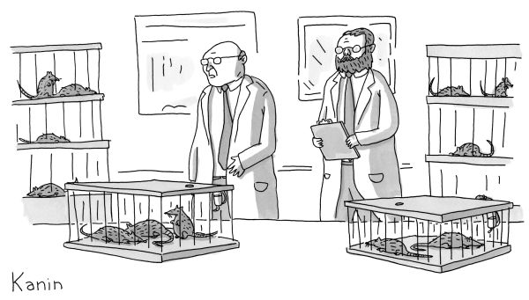“We gave cocaine to some and not to others, and now there’s a full-on drug war.”Buy the print »
Italians who admire Matteo Renzi call him “our best hope.” More skeptical Italians say, “Well, maybe our only hope.” The Western press hedges its bets with “brash” but “confident.” And his enemies use the term il rottamatore, the demolition man. Renzi agrees with his enemies. “I’m the scrapper,” he told me. “I’m cleaning up the swamp.” He meant the waste, the deadly bureaucracy, the notoriously padded ranks of Italy’s public administration, the unemployment now at forty per cent among the country’s youth, the outrageously slow pace of the justice system, the culture of cronyism, political perks and payoffs, tax evasion, casual everyday criminality, and open cheating—not to mention the various mafias, from the Cosa Nostra to the Camorra and the ’Ndrangheta, that still hold much of the economy of the South (and not a little of the North) in thrall. “We love Italy, I think you love Italy, everybody loves Italy,” Renzi had told the Council on Foreign Relations one morning last September, during a trip to New York for the opening of the United Nations session. “This is the risk for my country.” The risk has been that, for Italians, loving Italy is a way of saying, We’re used to the swamp we have, we know our way around in it—why bet on a future that might be worse?
“They love their past, their present, but they need a vision and an explanation of their future—in the possibility of a future,” Renzi told me that night, flopping onto a couch in the living room of his hotel suite. It was nearly ten hours since I’d heard him speak at the C.F.R., and he was exhausted from a day of interviews and speeches but waiting up for a call from the French President. “The mentality of Italy has to change, because reforms aren’t possible without everybody’s participation. We’re a young team—we want to invest in the new generation—but we’re not simply a young team. Youth is the man of whatever age who risks believing in the possibility of change.”
Renzi had moved into the Palazzo Chigi, the Prime Minister’s official residence, with a to-do list. “A reform a month,” he promised. He was going to radically change the labor market in Italy, with a Jobs Act that would offer financial protection for new, young workers while, at the same time, giving employers the right (a first for Italy) to lay off any workers in cases of economic pressure, with no obligation to rehire them; reduce the maddening ineptness of public administration; reform the justice system to shorten the process for civil cases; remake a parliament swollen to more than a thousand extravagantly paid members; generate foreign investment, then running at half the E.U. average; confront corruption with “values”; rewrite the election laws to produce a majority-rules system; and, of course, wrest “the story of Europe” from Angela Merkel. In January last year, a month before he became Prime Minister—with the hard-core labor wing of his center-left Democratic Party already stonewalling but with much of Italy distracted by his infectious litany of transformation—he struck a deal with Silvio Berlusconi that would help get his reforms passed.
Berlusconi was Italy’s Prime Minister three times in the seventeen years between 1994 and 2011. He spent nine of those years in office—thanks in large part to Forza Italia, the party he founded, and funded with his own money, in order to protect a financial empire that had made him Italy’s richest man. (His fortune now stands at $7.6 billion.) As Prime Minister, he was also its most legally unaccountable man. He was not solely responsible for the “swamp,” but given that, in office, he controlled ninety per cent of the country’s media—his own private media monopoly, Mediaset, and RAI, the state radio and television networks—he could celebrate his insouciant immunity and, more to the point, make it glamorous and entertaining. That running joke came to a halt in 2011, when Italy’s sovereign debt rose to $2.6 trillion and Berlusconi, losing a vote of confidence in parliament, had to resign from office. Two years later, after dozens of criminal investigations, he was banned from politics when a tax-fraud case, dating from the year of his resignation, became the first of his lower-court convictions to be whisked through the appeals process, and upheld, before the statute of limitations could kick in. (Given the state of Italy’s justice system, two years counted as overnight.)
When Renzi took over the government, Berlusconi was about to start serving a suspended sentence that obliged him to devote four hours a week to community service, tending Alzheimer’s patients at a nursing home near Milan. Many of his parliamentary deputies had defected by then and formed their own party, the New Center Right—they vote in a coalition with Renzi’s party now, and one of them, Angelino Alfano, is his interior minister. But the rest of Forza Italia remained a considerable presence in both houses of parliament, ready to do Berlusconi’s bidding.
Renzi’s deal with Berlusconi was negotiated at Democratic Party headquarters, on the Largo del Nazareno, with a Democratic deputy named Lorenzo Guerini representing Renzi and Gianni Letta, Berlusconi’s longtime éminence grise, representing the other side. It quickly became known as the Nazarene Pact, and though it was never published or even, presumably, written down, no one denied what was in it. Berlusconi pledged Forza Italia’s support for two of Renzi’s key reforms. One involved transforming the country’s chaotic version of a proportional electoral process into what Roberto d’Alimonte, a well-regarded political scientist who had helped draft the reform for Renzi, called a simple “majority-assuring system”: the party whose list of candidates won at least forty per cent of the vote would get fifty-four per cent of the seats in parliament, and could form a government of its own; if no party won forty per cent, the two lists with the most votes would compete in a runoff, and the winner would get the government. Renzi put it this way when we last talked: “In Germany, Angela Merkel was forced to have a grand-coalition government. I joke with Angela that, with my electoral law, she could be Chancellor free and clear.”
The second reform involved amending Italy’s postwar constitution, a document desperately, if understandably, democratic in its intended checks and balances. No new law could be enacted unless or until both the Camera (the chamber of deputies) and the Senate agreed to the same document, with exactly the same wording—one reason that Italy has been left endlessly recycling old Prime Ministers through a series of unstable new alliances. (Renzi’s is the sixty-third government in sixty-nine years.) Renzi’s idea was to abolish the Senate in its present role, transforming it, greatly reduced in size, into an assembly in some ways similar to the German Bundesrat. It would deal mainly with regional affairs, play no part in the creation (or the collapse) of the country’s governments, and leave the important national legislation in the Camera’s hands.
In return, Berlusconi expected a say in the selection of the country’s next President. The Italian Presidency is a largely ceremonial post, but in times of crisis the President has critically important powers. He (there has never been a she) has the right to dissolve parliament and call for immediate elections or, alternately, to appoint a new Prime Minister to form a government and serve until the current five-year election cycle ends—which, in fact, is how Renzi got the job. The President also has the right to grant pardons and commute sentences, which in Berlusconi’s case would possibly lift his ban, at least until the next conviction. (This spring, Berlusconi went on trial again, in Naples, charged with bribery.) Given that in January of 2014 the President, Giorgio Napolitano, was eighty-eight and longing to retire, and that Berlusconi, a surgically youthful seventy-seven, was longing for a comeback, Renzi got his pact.
In one sense, the pact could be seen as an American-style crossing of the aisle, but it amounted to revolution in a country where ideology had long taken precedence over accommodation. Renzi faced the inevitable backlash from the left of his party with a shrug and a few choice words, knowing, perhaps, that in the matter of craftiness he was miles ahead of the man whom no politician in Italy had ever managed to outfox before. (“Whom should I have talked to? Dudù?” he demanded. Dudù is a miniature poodle owned by Berlusconi’s girlfriend.)
While the left cried betrayal and Berlusconi cheerfully waited for absolution, Renzi quietly pushed the Presidential candidacy of a Constitutional Court justice named Sergio Mattarella, who, at seventy-four, had spent his life battling Italy’s criminal classes and their political allies, Berlusconi among them. (Mattarella’s older brother, a reform governor of Sicily, was gunned down by the Sicilian Mob in 1980, at the age of forty-five.) When it was all over, the Democrats’ recalcitrant leftists fell in line behind Mattarella, and then it was Berlusconi who cried betrayal. Mattarella became President in January this year. The Nazarene Pact is a thing of the past, but so, it appears, is Berlusconi.
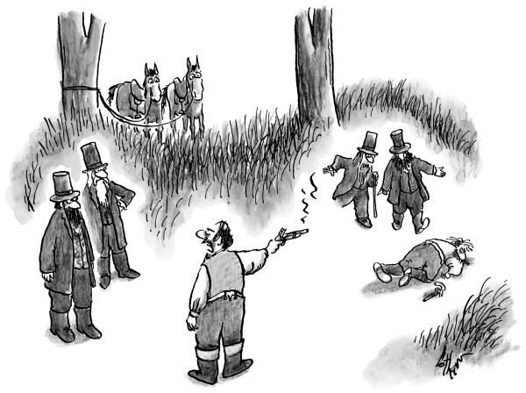“The ten paces were too much of a hassle.”Buy the print »
Renzi isn’t much of a reader. It’s unlikely that he keeps “The Prince” on his night table, but somewhere along the way to the Chigi Palace he learned one lesson from the wiliest Florentine of them all: a leader takes no prisoners where his ambition to rule wisely is at stake. There is no doubt that Renzi wants to save Italy from itself, or that he considers himself the only person who can do that. At home, he goes on the attack. “Plots, secrets, fake scoops, bollocks, and backward thinking: it takes just one night of watching television to understand Italy’s talk-show crisis” was one of his tweets at the end of January. A month later, he announced a plan to transform the compromised state media networks into an independent public corporation chartered on the order of the BBC. He reserves his homilies for inspirational speeches and the foreign press.
“I come from two experiences,” he told me one afternoon in Rome. One involved the four years he spent refereeing amateur soccer games, in Florence as a young man, and having to think on his feet and “to decide in seconds: this is the foul, this is the red card.” The other involved his fifteen years as a Boy Scout, developing a passion for public service—“for the res publica” is how he put it. You would have to add Catholicism to that short, formative list. In Italy, the Boy Scouts are not just tents and trails. They are under the aegis of the Church.
Renzi was born into a devout Catholic family. His father, Tiziano, is a Florence businessman who for years was a Christian Democratic assemblyman, and Matteo himself is a churchgoing Catholic, married to a like-minded schoolteacher and former Girl Scout whose brother is a priest. Roberto Cociancich, a Milan lawyer and Democratic Party senator, met Renzi when he signed up for a Boy Scout leadership-training camp that Cociancich was running in Tuscany. “Matteo was twenty then,” he told me. “There were forty people training in the camp, but after a couple of days I knew that this young man was somebody special. He was brilliant, capable—so capable that I asked him to join my training team. In the Scouts, we put a lot of emphasis on becoming good citizens. Our mission is to produce leaders, and we see the political life as an instrument for this. So I urged him to consider that life. In 2013, he called me and said, ‘Twenty years ago, you told me to choose a political life. Now it’s your turn’—so I ran for the Senate, and here I am.”
Renzi likes to quote his mother—an obligatory male ritual in Italy. He says that she used to tell him stories about Robert Kennedy “fighting for justice in the sixties, in America,” and that she always ended those stories with the words “Matteo, fight!” His communal spirit as a young leader seems to have done little to dampen that imperative. His easy camaraderie notwithstanding, he grew up with an appetite for the fray and a mean competitive streak. At nineteen, he was a contestant on Italy’s version of “Wheel of Fortune.” He was a little chubby then, and his getup was provincial (brown suit, big wide-knotted tie), but he won three weeks in a row before being beaten, and took home some thirty thousand euros in prize money. At twenty-seven, he left the small party where he had been provincial secretary to become the local leader of the Daisy, a center-left coalition that in 2007 merged into the fractious ranks of the newly created Democratic Party. At twenty-nine, he was elected president of Florence’s provincial council. Five years later, he decided to run for mayor. When he won the Democrats’ nomination and then the election, he softened the blow to a friend named Dario Nardella, who had apparently hoped to be mayor himself, by appointing him as his deputy mayor and obvious successor. “Matteo is committed and tough, but it’s to lead, not to control,” Cociancich said. Actually, it’s both.
Renzi was the third Prime Minister appointed by Giorgio Napolitano in the years since Berlusconi left office, in 2011. The others were “technocrats,” a euphemism for “experts in another life.” The well-known economist and former European Commissioner Mario Monti was brought in first, to tackle the mounting debt crisis that Berlusconi had failed to manage. Two years later, Monti made the mistake of running in the national elections—with no political base beyond Civic Choice, the small party he had patched together to support him—and was trounced. Enrico Letta came next. He lasted ten months before Napolitano replaced him. Letta was directing a think tank when we first met, in 2007. Eight years later, he described his months at the Chigi to me this way: “I wasn’t a ‘communicator.’ I didn’t run an administration of a hundred-and-forty-character bites.” Renzi’s public assault on Letta began with a condescending tweet: “Stay calm! Nobody wants your job.” The message was clear. The next day, Letta drove to the Quirinale to offer his resignation to Napolitano. By evening, Renzi was Prime Minister.
Renzi’s plan then was to move to general elections quickly. He wanted fresh and appealing faces in his cabinet, to signal the end of those old pols, laundered and recycled through most of the governments that preceded his. Predictably, he opted for youth and women—the obvious appealing things. (Renzi told me that the average age of his cabinet was forty-seven; eight of the sixteen ministers he appointed were women.) It worked. A few months later, riding the wave of Renzi’s popularity, the Democratic Party won forty-one per cent of the vote in Italy’s European parliamentary election. It was a spectacular victory for Renzi—better than any Italian party had done in any election since 1946, and certainly enough of a mandate to free him from the risks of calling general elections at home. He bought the time to negotiate his reforms.
“Renzi is a pure politician, one of the toughest I’ve seen in years,” Franco Bernabe, the chairman of the Italian financial-advisory boutique FB Group and a former head of ENI, the state energy company, and Telecom Italia, told me. “He picks up very quickly on the essence of power. He’s not very deep intellectually, but he has a fantastic ability to take up and absorb good ideas. He had only local experience when he came to Rome, but he already had a European agenda, he understood completely the problems of Italy, and he could get that message across. Monti had failed spectacularly at that, and Letta even worse. I, of course, welcomed a man with the right vision and understanding, and if he didn’t listen to every old pol, so what? He was anxious to get rid of that older generation. They would happily have got rid of him.”
In Florence, Renzi had been immensely popular as mayor. He halved the size of an overstuffed city council, installed free Wi-Fi centers across the town, and increased the budget for social services and preschools. He found patrons for art projects and exhibits like “Sculpture in the Age of Donatello,” which spent this spring at the Museum of Biblical Art, in New York. He also closed Florence’s Renaissance city center to traffic. The tour buses disappeared. It was a change that tapped into the pride that Florentines take in their history. It also meant that the center could be reclaimed, or at least shared, by the natives. (Renzi, who revered Steve Jobs, told me that Jobs liked to compare the two great Renaissances: Florence and Apple.)
But what really made Renzi’s national reputation were the Leopolda, annual public conclaves that he inaugurated a year after his election, on the advice of his deputy mayor for culture, in a converted nineteenth-century railway station of the same name. The Leopolda were all-day happenings on the order of a political human be-in. Thousands of people came to talk and listen. The only rule was that everyone had to say whatever he or she wanted to say in five minutes or less.
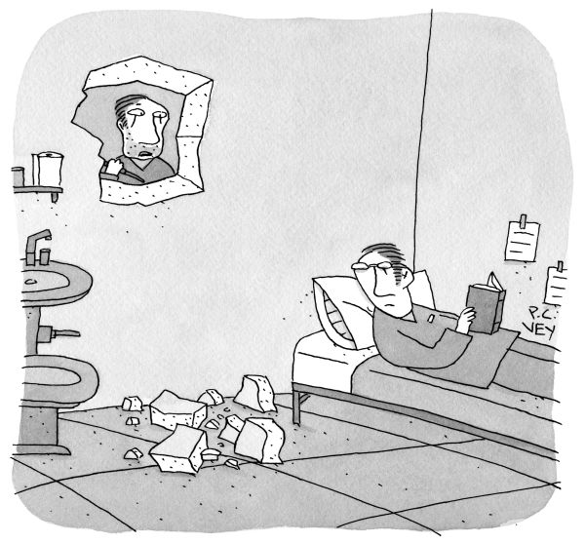“Oh, sorry. I thought this was an exterior wall.”Buy the print »
Edoardo Nesi, a Tuscan writer and filmmaker who has been a deputy in the Camera for the past two and a half years, got to know Renzi in Florence, after Renzi talked about his book “Story of My People” at the first Leopolda. The book was a memoir, about the small family fabric factory that Nesi ran briefly and had to sell when competition from China began forcing Tuscany’s old fabric-makers out of business; it got a lot of attention in Italy because of its evocation of people fighting for dying local traditions in a global world. Nesi called Renzi to thank him. “Matteo said, ‘Come to the next Leopolda and talk,’ ” Nesi told me. “So I did. Four or five thousand people were there that day, listening and talking, and the idea of something like that, something political, starting from the people—it confirmed my feeling that Matteo was necessary for Italy. It was his idea that Italy had to change, that Italy had been living for years concentrating on its past without connecting to its future, that Italy was in decadence.” I asked Nesi why he’d run for parliament, and he said, “I had this feeling that Italy was up for grabs, this feeling of urgency and fear, so I thought it was good to give a little of my time to public service—and also because this moment, in Italy, this is fantastic material for a writer!”
It’s been said that Renzi’s “Rome” is the elevator between his office on the first floor of the Palazzo Chigi and his official apartment on the third. His wife, Agnese Landini, remains in Florence, where their three children go to public school, and where Landini teaches Latin and Italian in a classical public high school. Most weekends, Renzi flies home to see them. They are rarely together at the Chigi. On the few occasions when the family spends a weekend in Rome, Renzi joins them at a seventeenth-century villa in a tranquil, outlying Roman park which for years has served as one of the Prime Minister’s official retreats.
“It’s fifty minutes on the plane, and I’m home,” Renzi told me, talking about his commute to Florence. “And that way I avoid the risks in bringing my family here. In Florence, they can continue a traditional life. A year ago, I didn’t have secret service. I used my bike. I talked quietly to citizens on the street. Now that’s over for me, but I want that same freedom for them. This job is an incredible responsibility. But this chair I’m sitting in—it isn’t the center of my life, but at this moment I work for my country. I’m focussed on changing my country. I feel the emotion of innovation, of the lab.” A minute later, he was recommending his “innovation video”—highlights from a whirlwind trip he’d made to Silicon Valley in the fall—which in turn reminded him that “Pope Francis decided to speak to the European Parliament on November 23rd, during my presidency of Europe.” (The presidency of the Council of the European Union is a rotating six-month post; Italy gets another turn in fourteen years.) Renzi counts that speech as an endorsement—a reform Pope and a reform Prime Minister in synch in their excoriations of church and state. He is an ardent Francis fan. He said that after the Pope warned Catholics that their “moral responsibility” did not include breeding “like rabbits,” the first thing he did was to call a prolifically procreating friend and tell him, “You can stop now!”
Lucia Annunziata, who covered national politics for Corriere della Sera and, in 2012, became the editor of the new Huffington Post Italia, says that Renzi’s stories are a constructed life, a way to enforce his image as a gentle knight on a noble crusade, with none of the vices that Italians have come to expect in their politicians. In fact, he has very few. He isn’t a womanizer. He isn’t corrupt, or even, by all reports, interested in money. One of his first appointments was Raffaele Cantone, a Naples magistrate who had heroically pursued the Camorra for twenty years. Renzi created an anti-corruption authority for Cantone—three hundred men and women working together from Rome to dismantle a system so criminally interconnected that Cantone described their job to me as “an unending process.” Renzi gave Cantone carte blanche and his office an independent charter. “I am not a friend,” Cantone, who barely knew Renzi when he took the job, told me. “I appreciate him. At the beginning, he asked me only one thing. He said, ‘Raffaele, if someone calls you in my name and asks something, or asks for something, don’t do it!’ ”
Renzi’s one vice may be his keen interest in controlling what he would call “the narrative” of his entitlement. Annunziata, who admired the Prime Minister at first, now counts herself a Renzi skeptic. “He has that Bill Clinton look,” she told me. “The one where he looks deep into your eyes, promising everything, and all of a sudden the look goes over your shoulder to the next person. There was always a mystery to him. He had the sagacity to know that his moment had come. He knew the extent to which Rome was rotten, and he was good at picking up on the old age and bankruptcy of the Democratic Party—that Italy was still all about postwar politics, left and right. He felt accurately the resentment in Italy, the stagnation. So he swooped down.” Like a knight? I asked her. “Like the Vandals,” she said.
Like any politician, Renzi courts the journalists who praise him and gives wide berth to the ones who don’t. But most reporters in Rome will tell you that Renzi has two governments—his official cabinet and house advisers and his Chigi kitchen cabinet of Tuscan strategists, otherwise known as the giglio magico, or magic lily, for the flower on Catherine de’ Medici’s coat of arms—and that access to the latter is blocked. (It was to me.) The one exception seems to have been a reporter from Il Foglio, a weekly paper with close ties to Berlusconi, who described the after-hours Chigi as a place in glorious disarray, where the young Tuscans are busy running Italy, barefoot in T-shirts, eating takeout pizza.
There is nothing new about politicians trying out their ideas and tactics on friends whose loyalty is first and foremost to them, and whose discretion is a given. Barack Obama installed his Chicago cronies David Axelrod and Valerie Jarrett in the White House. David Cameron gave pride of place at 10 Downing Street to his plummy Eton crowd. The difference, with Renzi, is that his giglio magico remains an open secret, and no one can say for sure whether it is actually “running Italy” with him or simply running errands.
Some of the Tuscans in Renzi’s kitchen cabinet are in his government, too—most famously Luca Lotti, a thirty-four-year-old under-secretary of state for publications, otherwise known as the Chigi’s most accomplished fixer. (Lotti, whose wife was Renzi’s secretary when he was mayor of Florence, was instrumental in arranging the meetings that produced the Nazarene Pact.) Another is Maria Elena Boschi, who studied law in Florence a few years after Renzi and is now, to mixed reviews, his minister for constitutional reform. And a third is said to be Francesco Bonifazi, a Florence lawyer and Democratic Party deputy who, with Lotti, is hoping to revive the defunct Communist daily L’Unita as a center-left “Renziani” newspaper. The others vary, depending on Renzi’s enthusiasm and on whom you ask. “In the end, it’s the inner circle that counts for Renzi,” Franco Bernabe told me. “With the cabinet, ‘young’ or ‘woman’ didn’t necessarily mean capable. . . . Some ministers performed, some didn’t. The difference, with the Chigi group, is that Renzi trusts them”—which is to say, they perform for him.
Last fall, Renzi sent his first foreign minister, Federica Mogherini, to Brussels to become the new European high representative for foreign affairs and security policy, and today she and her replacement at the ministry, Paolo Gentiloni, have the difficult job of garnering European support for the possibility of Italian troops in Libya. ISIS is now a major player in Libya’s civil war—which, as Renzi said when he first threatened to intervene, in February, puts terrorists two hours by boat from Italy’s shores. During his first year in office, a hundred and seventy thousand refugees from the violence in Africa and the Middle East arrived on southern Italy’s islands, most of them plucked from the sea by Italian Navy ships, or from the sinking rubber boats of their Libyan traffickers. The ships were part of a humanitarian patrol-and-rescue mission called Mare Nostrum (Our Sea), which Letta’s government initiated in the fall of 2013, and which Renzi had to cancel a year later, under pressure from his coalition and, more significant, from E.U. members who argued that the success of Mare Nostrum’s rescue operation was actually encouraging migration: too much, at any rate, for a continent already packed with refugees and migrant workers to handle. The E.U. replaced Mare Nostrum with a much smaller operation called Triton, and confined it to sea and air patrolling—in other words, to deterrence. Whatever refugees it did rescue were deposited in Italy.
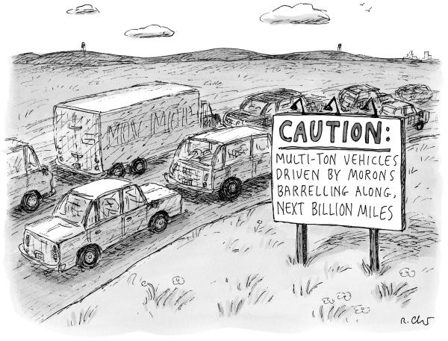Buy the print »
Renzi, in a widely circulated op-ed in the Times in April, called Triton “dramatically inadequate.” He pleaded with Europe to take on its humanitarian share, pointing out that Triton’s budget was a fraction of Mare Nostrum’s, and amounted to only forty million euros out of the yearly E.U. budget of a hundred and forty-five billion. Less than a month later, the European Commission proposed a formula involving an emergency refugee-quota system for each of its member states, based on the state’s size, solvency, unemployment figures, and pending asylum claims. Its future is uncertain. (Britain, France, and Spain have already refused to participate.) Today, with human trafficking fast becoming one of Libya’s only profitable businesses, and refugees still arriving in huge numbers—upward of fifty thousand so far this year, not to mention the more than seventeen hundred and fifty who drowned trying, including eight hundred in a single day—the burden for Italy is undeniable. Last month, the Italian police arrested a Moroccan man who had entered Italy with a boatload of refugees in February and was now wanted for providing “logistical support” to the massacre at a museum in Tunis in March.
At the beginning of this year, Italy’s sovereign debt—moneys owed by the state to all public and private lenders—was 2.16 trillion euros. Monti had tried to stem the debt with rigorous “European” measures, and failed. Letta had simply failed. Now it’s Renzi’s turn. None of his other reforms will mean much unless he can turn around the fiscal and economic crises he inherited. Napolitano is said to have put one condition on appointing him, and that was that Renzi choose a finance minister with international experience and standing. At the time, the most that anyone knew about Renzi’s economic views was his belief in what could be called global capitalism as a transformative—which is to say, potentially progressive—force for social and economic change. He was said to be getting economic advice from a Democratic Party deputy named Yoram Gutgeld, a veteran of twenty-four years with the growth-management giant McKinsey, and trying it out on one of his closest friends in Florence, Marco Carrai—a successful young businessman and investor whom, as mayor, he had installed as president of the Florence Airport. Carrai is not an economist. Among other pursuits, he is developing security technology in Israel, and he shares Renzi’s strong support for the country in an increasingly dismissive Europe.
Renzi made his decision quickly. The man he tapped for the ministry of finance and the economy was Pier Carlo Padoan, a sixty-five-year-old veteran of the International Monetary Fund and the Organization for Economic Co-operation and Development, where he was the chief economist and deputy secretary-general. He came to the job with no political agenda but with a lot of good will from Europe, and a strong sense of the problems he was about to face.
“My view of what needs to be done is to address a combination of three problems that have been rigid impediments to our growth,” Padoan told me. “And we need to do that now. One is boosting growth through tax cuts for both companies and households. Another, of course, is supporting innovation.” (Renzi, returning from his “innovation” trip to California, had promised Italy its own Silicon Valley.) “And the third is introducing the kind of structural reforms that could lead to a new European Code—one that specified that countries implementing sound reforms could benefit from an allowance if the investment involved was seen as promoting incentive and growth.” He said that the budget law under discussion would “change the logic by which public money is used.” And the ongoing tax reforms would not only simplify taxes but “change the taxpayer’s relation” to the taxes he has to pay, which is to say that tax evasion—a national pastime that Berlusconi decriminalized in 2002 and Renzi recriminalized this year—has been redefined to include the off-the-books jobs that are said to account for up to twenty per cent of Italy’s economy.
Padoan was expected to have a tempering effect on Renzi, but Renzi is a notorious micromanager. “Oops, there’s a text from Mr. Renzi, he always texts,” Padoan said, a few minutes into our conversation, texting back. Minutes later, he got a second text. He answered it, and not much later his cell phone rang. He took the call, laughing. “It’s Mr. Renzi again,” he told me. “It’s normal. That’s Renzi.”
Then, too, Padoan’s instincts are incremental: first Italy, then the world. Renzi’s are the world. In December, he added Andrea Guerra—the former C.E.O. of Luxottica, the global eyewear company that owns Ray-Ban—to his Chigi team of senior economic advisers. The team is led by a like-minded state secretary for international economic affairs named Marco Simoni, whom Renzi met when Simoni, a young professor at the London School of Economics, came to speak at the first Leopolda. “The paradox is that, in the past, Italy passed plenty of economic reforms, but they were badly conceived and badly executed,” Simoni told me. “There was no defense of income, no economic protection. We are definitely free market. But unlike Mrs. Thatcher—she’s the example we use in England—we want growth and social justice, and the fact is that countries that have externalized more, that have looked to the huge developing markets in India, China, South America, end up with a better, fairer economy at home. Our point? You can’t divorce your national and international agenda. It’s one single polity now.”
Italy’s Democratic Party, in its new, “Renziani” incarnation—think Clinton-Blair for the twenty-first century—is a warring clan of former Communists, Socialists, Social Democrats, Christian Democrats, and liberal entrepreneurs, each faction circling the others warily and hoping they will go away. I sat in on the Party’s board-of-directors meeting, on the Largo del Nazareno, late last winter. Renzi gave the opening speech. It covered the subjects he wanted to see discussed, from the attacks in Paris to the progress in Brussels, the construction-kickback scandals then surfacing in Milan, the parliamentary chaos that had left one house debating electoral reform and the other public-administration reform, and, finally, the lazy pace of the Party’s own discussions about those issues. “This isn’t a joke; discussion is not ‘optional,’ ” he said. But the only thing that most of the other speakers wanted to “discuss” was the result of a regional primary election in Liguria that Renzi’s handpicked reform candidate had won and his opposition on the left—having forced, and lost, a recount—was still protesting. Some twenty board members stood up, one by one, and presented mind-numbing catalogues of their complaints. Renzi listened for three hours, texting and typing notes, and then he looked over the notes he’d made and responded to each complaint in increasingly exasperated detail. But his closing message was succinct: No more Liguria; Liguria is over. Let’s practice being united. Stop blocking my electoral reforms, and let the party that can win this—that’s us—govern.
“I keep saying, ‘Matteo, you have to run, run, run for the solution, because if you run fast the solution to your problem comes,’ ” Renzi’s friend and arguably most colorful supporter, Oscar Farinetti, the paterfamilias of the Eataly food-emporium empire, told me a few days later. “Matteo and I are both so busy, but in the morning, at six, we text. For six months, it’s been about the eighty-euro thing.” He was talking about an eighty-euro-a-month tax credit that Renzi started giving to low-paid workers last year, hoping to stimulate spending; by all indications, they were saving the money instead. “Matteo asks, ‘How about Eataly? Is business growing?’ At first, I had to say ‘No!’ But suddenly, in December, I could say ‘Yes!’ People started spending, and they haven’t stopped. I tell him, ‘Matteo, humans aren’t perfect. To manage the imperfection, you have to keep at it.’ ”
When Renzi talks about his enemies, first among equals is always his own left wing. “My opposition on the left is an ideological one,” he once told me. “I don’t think it’s important to discuss anything with them anymore.” He is far more comfortable with his center-left, center-right coalition, perhaps because, in the end, he likes the idea of “center” best. But his enemies list remains long. There are still Berlusconi loyalists in parliament, though by all reports that loyalty is fizzling now. More seriously disruptive are the comedian Beppe Grillo’s Five Star Movement, on the populist left, and Matteo Salvini’s new “national” Lega party, on the populist right, both competing for the same anti-Europe, anti-immigrant votes. They keep Renzi busy, however undaunted he claims to be.
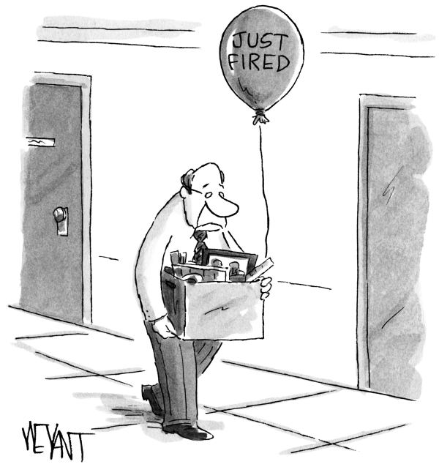September 27, 2004Buy the print »
Grillo founded his gadfly party in 2009, and the fans who had flocked to his standup act now flock to his rallies in the Piazza del Popolo. “I’m a performer, and when there’s a strategy I know it,” he told me. “Renzi says, ‘I did this, we did that,’ and people think he’s the last chance for Italy, but, no, he’s the last chance for the bankers.” It was hard to tell whether Grillo was railing against the notion of a transformative capitalism or about the fact that Renzi, who had begun to unblock the country’s electoral system by abolishing state subsidies for political parties, was raising money for his own party from investment bankers and financiers (among them James Pallotta, the American hedge-fund manager and now the president of the soccer team A.S. Roma). Grillo’s party, which is mainly a volunteer Internet operation, has little or no money. It also happens to be the second-largest party in the Camera, although its power to do anything besides filibuster is nonexistent. Grillo forbids his deputies to enter into a coalition, and even removes the ones who disagree with him. (In a way, Renzi owes his job to Grillo, who refused to form a governing coalition with the Democrats after the parliamentary elections in 2013, when their party leader was the labor-left politician Pier Luigi Bersani.)
David Allegranti, a young journalist in Rome, told me, “Grillo as a threat? Come on! There are Grillo deputies who believe in mermaids; there are deputies who believe that the jet streams you see in the sky are chemical weapons!” Allegranti, who comes from Florence and has written two books about Renzi, said that the Prime Minister cultivates his image as a man beleaguered by crazies because it makes him seem “more essential” to saving Italy. Maybe. Last year, Grillo made the perhaps inevitable mistake of allying his Five Star Movement with Britain’s far-right United Kingdom Independence Party, in an attempt, eventually thwarted, to form a secessionist bloc in the European Parliament. People quickly predicted that he would self-destruct. They were wrong.
Then there is “the other Matteo”—Matteo Salvini—and his “new” Lega. In the days when Lega was the powerful junior partner in Berlusconi’s coalition, it was known as Lega Nord. Its cause was separatism—Italy as a federation of fiscally independent regions—the idea being to free the prosperous North from having to pay the bills of an impoverished and, as Salvini puts it, “culturally different” South. Salvini, who took over Lega Nord in 2013 (a year and a half after its founder, Umberto Bossi, came under investigation for siphoning large amounts of party money to restore his house, an allegation he denied), has a bigger canvas. “I wish all the bad possible for Renzi’s reform plan,” he told me, on a call from Milan. “As for Angela Merkel, I say, ‘Brava!,’ for trying to defend the interests of Germany in Europe, but we are not interested in Europe. We are interested in Italy.” To that end, he has dropped the Nord from most of his speeches and has gone national with the Party. He said that the growth of Lega in central Italy had persuaded him to “coördinate all Italy” under an anti-Europe and anti-immigration banner. (“Only qualified immigration” is how he pitched this to me.) He has found a champion in France’s Marine Le Pen and her ur-Nationalist allies in Austria and Holland, and dismisses Grillo as “much too soft on immigration.” (Grillo wants Italy out of Europe more than he wants immigrants out of Italy.)
Renzi’s concern is that terrorists now fighting over Libya could slip into Italy, undetected, in the boatloads of refugees trying to flee them. Salvini’s concern is that anyone arrives at all. He claimed that there were “twenty-five hundred Islamic cultural centers and mosques in Lombardy” alone, and talked about veiled women all over the housing projects and a proliferation of Islamist media and schools. He called it a transformation “such as we have never seen before.” In February—heartened, he says, by the support for Lega in central Italy—he launched his campaign for the South, where xenophobia can be fuelled by ignorance, fear, and racist propaganda in pretty much equal measure.
“I went to Strasbourg to speak last year, during my E.U. presidency, and Grillo’s people were shouting ‘Mafia!’ at me, and, when I mentioned Dante Alighieri, Salvini started mocking art,” Renzi told me. He talked about listening to Obama’s State of the Union address, and how much he “appreciated the respect” that the President got. (If he had watched it instead, and seen the Tea Party contingent smirking, he might have thought again.) “This year, I will change Italy or change jobs,” Renzi said, not for the first time. “The far left is not in a position to stop my government, only to vote against it and call strikes. But the people know that this is the moment when Italy must change. The old Democratic Party got twenty-five per cent of the vote in the last national elections, but, remember, my Democratic Party got forty-one per cent in the European elections last year—that’s sixteen percentage points in one year.”
Renzi complains about the left as often as he dismisses it. For all his bravado, he is easily aggrieved, a quality he shares with Berlusconi and, like Berlusconi, uses to elicit sympathy and support. Sergio Rizzo is an investigative journalist for Corriere della Sera and the co-author of “La Casta,” a best-selling book about the extravagant corruption of Italy’s political classes. He told me, “I think that Renzi can change the politics here, I really do, but the serious problems are that he’s very close to power, and, more important, that he tolerates only people around him who agree with him. He doesn’t take well to being crossed. Now when he has an announcement to make he doesn’t make it to his party; he goes on television instead.”
Carlo Freccero, who once ran Berlusconi’s French television channel La Cinq and came home to run a channel for him at RAI, calls Renzi “Berlusconi 2.0”—someone who grasps completely the extent to which, in Italy, politics is theatre and successful politics is a one-man show. It’s a tradition as old as the Roman emperors, with their triumphal parades and eviscerating circuses. Mussolini emulated it for twenty years, with dire consequences for the country. Berlusconi turned it into opera buffa, was in office longer than any other Italian Prime Minister, and ended up in court. “In one way, Renzi is a monument to Berlusconi,” Freccero told me. “He is a man of spectacle, of entertainment. He knows that ‘communications’ today is a trompe-l’oeil, and he’s embraced the reality of that, and the language of that. It’s a ritornello, a continual refrain: ‘Be America! Be the future! Take back the narrative of Europe! Compete!’ He wants to be every Italian’s selfie.”
Giuliano Ferrara, who founded Il Foglio and edited the paper until this year, said, “There’s something very psychological between Renzi and Berlusconi. Berlusconi has no political heirs, so Renzi is the royal baby. When Renzi was mayor of Florence and Berlusconi was under siege by the magistrates, Renzi went to his home in Milan and had a very human meeting with him. I admired that. And when he became Prime Minister he said, in effect, ‘I want to compete with you, not destroy you.’ ” That, of course, is what he is saying to Angela Merkel now.
Despite the populist filibusters and the grumbling of the ideological Old Guard, Renzi has managed to transform the political landscape of Italy in not much more than a year. On May 4th, his electoral law passed the Camera. The warnings before the voting had been strong. The editor of Corriere, referring to Francisco Franco, called Renzi a “young caudillo.” The editor of La Repubblica called his bill “weakness, disguised as a show of strength.” And one of the Democrats’ rebel-left leaders, Giuseppe Civati, described it as “genetically modified Presidentialism” and promptly quit the Party, with plans to start a new one of his own. Inevitably, more defections followed, and several Democratic deputies let it be known that they would vote against the law. Renzi had turned the electoral vote into a vote of confidence; the balloting was secret. Most of the opposition parties—including, on Berlusconi’s orders, Forza Italia—refused to vote or walked out. But the bill passed easily without them. After the votes were counted and the news went out (334 in favor, 61 opposed, 4 abstentions, 235 walkouts), it was clear that most Italians liked the prospect of electing governments that might actually last their five-year term. Corriere announced that Renzi “is today, and probably will be for a long time, unbeatable, unsinkable.” The law is due to go into effect at the end of June, 2016, assuming that the Constitutional Court approves it.
Renzi, meanwhile, was making the television circuit. It’s now likely that his constitutional-reform bill will go straight to a national referendum later next summer—and the Senate, which he had first planned to overhaul this summer, will be radically transformed by constitutional change. An early election could come next. But Renzi must have expected to take some knocks by then, and it turned out that he got them quickly, when, late last month, seven of Italy’s twenty regions held elections.
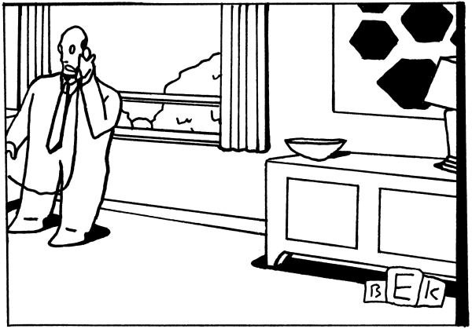“You’ll have to excuse me—I’m myself today.”May 14, 2001Buy the print »
In Liguria—which definitely wasn’t “over”—the Democrats’ left-labor wing ran its own, breakaway candidate, splitting the Party’s vote, with the result that a coalition of the right took the region. And while the Party did win five of those seven regions, the vote was nowhere close to its benchmark forty-one per cent in Europe last year. The problem for Renzi was in part apathy. Voters in Italy tend to sit out local elections unless there’s money or a grudge or a job or old loyalties at stake, but the low turnout also contained a message. Renzi may have promised the country too much, too fast, for any politician to deliver.
Renzi, who left the country on a “surprise visit” to Italian troops in Afghanistan as the election returns came in, called them “very positive,” and produced a short statement saying, “We will push forward with even more determination in the process of renewing the Party and changing this country”—after which he ignored them. It wasn’t the worst response. Employment was rising; growth projections, which had been negative since Italy’s latest recession began, in 2012, were back above the zero line; and consumption, as Renzi put it after the G7 summit in Bavaria this month, was “showing signs of a reawakening.” People can admit to being optimistic.
Earlier this year, I had asked Marianna Madia, Renzi’s minister for public administration, how he did it, and she said, laughing, “Velocity and rupture!” When I put the question to Graziano Delrio, his former chief of staff at the Chigi (and now, in the wake of the construction scandals in Milan, his minister for infrastructure), he said that the mantra was: Decide, then we’ll see. “We wanted to give a violent shock to the Italian system,” he told me. “To the psychology, yes, to the culture, yes, but also to the economy, to labor, to business. And most important was that we started. We had a system based on nepotism and seniority. But our duty was to prepare our young people for taking power, and those young people didn’t want to wait in line while the old system got worse and worse.” A moment later, he added, “It’s been quite difficult for us to forge a social contract in a country of so much adventurism and so little clarity in its institutions.”
It may be that, in the end, Matteo Renzi’s future in Italy depends on his future in Angela Merkel’s Europe. Many of the politicians I talked to complained about their frustration in finding common ground with the E.U.’s northern states. “We are not the United States of Europe” is how Delrio put it, talking about the days when Jean Monnet and Robert Schuman, the union’s founding fathers, could look to carbon and steel as the way to create unity and address poverty in a devastated continent. Seventy years on, the stakes are different and the battle lines are drawn in cash.
Merkel is a Lutheran pastor’s daughter who grew up in East Germany during the Cold War, when thrift was not an option but an order of the Politburo. In West Germany, recovery began early, with the Marshall Plan, and continued under an Allied occupation that lasted ten years. Its bombed-out cities and factories were rebuilt and, slowly, its infrastructure was restored. Konrad Adenauer, who in 1949 became the first postwar Chancellor of the Federal Republic, was a Roman Catholic, but there was also a cool Lutheran frugality lurking inside him. He was in office for fourteen years, when thrift was an option. He took it. So did Helmut Kohl, who was Chancellor in the nineteen-nineties, when the Federal Republic absorbed East Germany. The country got fat and rich during all those years, but in hard economic times its governments followed the dictum “Don’t borrow, don’t spend.”
Italy, at the beginning of the Second World War, was still largely an agrarian country. Most of its contadini were illiterate; its agricultural arrangements in many regions were close to feudal. And “infrastructure” meant the family, the Church, the party, and, in much of the South, the mafias—umbrellas of support, protection, and, of course, jobs, under different names. In that sense, Italy emerged from the war unchanged. You took care of your own, bought into the swamp, and ignored the indicators of collapse. The perimeters of a good life depended on the umbrella under which you sheltered. You built your house there, put your money under the mattress, and did not invest in anything beyond it. The government did that for you. By the seventies, it was spending and spending, spreading a patchwork quilt of employment and subsidy over your mattress. By the mid-nineties, when the reformist Prime Minister Romano Prodi was elected and tried—and failed—to mend it, the country was going broke. When Mario Monti tried, it was broke, and, as for Enrico Letta, he didn’t stand a chance. Today, when Matteo Renzi asks for stimulus money for recovery, he is starting practically from scratch. The one thing his Italy shares with Merkel’s Germany is the reality of a European divide.
Monti told me that, when he was Prime Minister and visited Barack Obama at the White House, Obama admitted to being at a loss to know “how to engage Merkel on matters of economic policy.” Obama asked his advice, and Monti replied, “For Germans, economics is still part of moral philosophy, so don’t even try to suggest that the way to help Europe grow is through public spending. In Germany, growth is the reward for virtuous economics, and the word for ‘guilt’ and ‘debt’ is the same.”
It’s safe to say that guilt is not a problem in a country of Sunday confessional absolution. This is a battle that Renzi has to win. “For me, the point is that Italy has come back into the discussion of ‘What is Europe?’ ” he told me, when we last talked. “In the past, the message was always that ‘Europe’ would teach Italy what to do. The real message now is that we are Europe. The perspective has changed. Politics needs passions. Otherwise, you are not the star, you are just a supporting actor.” I asked how long he was planning to play the leading role, and he said that, if all went well, he would be able to get the country to its next scheduled parliamentary elections, in 2018, and then, if he’d been successful and “the people want it,” he would run again—in which case, “on February 22, 2024, I’ll leave. I’ll study. I’ll become a professor!” ♦

